A
PROJECT REPORT ON
STATISTICAL STUDY ON STOCK MARKET
SUBMITED
TO


DEPARTMENT OF STATISTICS

PUNYASHLOK AHILYADEVI HOLKAR
SOLAPUR UNIVERSITY, SOLAPUR.

.

BY

BHAGWAN KIRAN PALMURI KARUNA A. GADDAM
PRANITA SATISH PHUKALE PRAGATI P. RESHIMKAR

UNDER GUIENDENCE
PROF. O.D. GHADAGE
Punyashlok Ahilyadevi Holkar
Solapur University, Solapur

CERTIFICATE

This is to certify that Mr. Bhagwan Kiran Palmuri, Mrs. Karuna Amar Gaddam, Mrs.Pragati Prakash Reshimkar and Mrs. Pranita Satish Pukale of M.Sc. Part- II (Statistics) has satisfactorily completed project on “Statistical Study on Stock Market” as per the syllabus Punyashlok Ahilyadevi Holkar Solapur University, Solapur during the academic year 2020-2021 under my supervision and successfully submitted the report.

Mr. O. D. Ghadge Dr. V.B Ghute
Project guide Examiner Head of Department of Statistics

Place: Solapur

Date:

ACKNOWLEDGEMENT
We would like to take this opportunity to express our deep sense of gratitude to all those people without whom this project could have never been completed. First and foremost, we would like to thank our respected Head of the department Dr. V. B. Ghute sir for their inexhaustible source of inspiration.
We would like to extend our gratitude to Prof. C. G. Gardi Sir, for his constant encouragement and providing very nice platform to learn.
We all are highly indebted to the teacher in charge prof. O. D. Ghadge sir for his guidance and constant supervision as well as for providing necessary information regarding our project and also for his support in completing the project..
We also thank our parents for their support.
THANK YOU.

INDEX

Sr. no. | Title | Page no.
1 | Introduction
2 | Objective
3 | Methodology
4 | Terminology
5 | Statistical analysis
6 | Conclusion
7 | Scope and limitations
8 | reference

Introduction

The first organized stock exchange in India was started in 1875 at Bombay and it is stated to be the oldest in Asia. ... The Calcutta stock exchange was started in 1908 to provide a market for shares of plantations and jute mills. Then the madras stock exchange was started in 1920.
A market is a collection of buyers and sellers, facilitated by a stock exchange, which enables the determination of price for assets, e.g. company securities. In the share trading context, a stock market is where share prices are set, and where the organic supply and demand for shares can play out in primary and secondary markets. The sectors of the Indian economy that seem to be many investors will be buying interest in the safer sectors such as FMCG, PHARMA,BANK,REAL. Therefore, it is advisable for investors to choose sectors with good growth potential, good market share and consistent profitability.

Objective

- Effect of BANK, FMCG, PHARMA, IT, and REAL on SENSEX and NIFTY.

- To predict future value of SENSEX and NIFTY nearly 1 year

Methodology
As we know Society became queries to learn and earn saving their money in Share Markets Or in mutual funds it became important for our future to enjoy healthy lifestyle. Our approach to select this project is to study how the fluctuations occurring in share market.
Our project name is ‘Statistical study on Stock Market’ . As we know share market is collection of buyer and sellers, facilitated by a stock exchange. Share market contains different sectors like Bank FMGC, PHARMA, IT and Real. Now we are going to study How the Sensex and Nifty are affected by Bank, FMCG, PHARMA, IT and REAL also prediction for next two years. For this Statistical study we collected secondary data from BSE. India. Com and . … .. … .. …
For Analysis we used tools like Regression Model, Time series Analysis and we used software to draw the plots and to make model tables.
Software used for Analysis:
1. Ms-Excel
2. R software
3. Minitab

Statistical Analysis
On
Stock Market



Regression Analysis

Fit a multiple linear regression model

In multiple linear regression, there are p explanatory variables, and the relationship between the dependent variable and the explanatory variables is represented by the following equation:

Y𝑖=β0+β1X𝑖1+β2X𝑖2+⋯ +β𝑝X𝑖𝑝+ε𝑖

Where 𝑦𝑖=Sensex value, Nifty value.
x𝑖=stock values for five sectors (BANK, FMCG, IT, PHARMA, REAL). Where, i=1,2,3,4,5
Where: β0 is the constant term and β1 to β𝑝 are the coefficients relating the p explanatory variables to the variables of interest. So, multiple linear regression can be thought of an extension of simple linear regression, where there are p explanatory variables, or simple linear regression can be thought of as a special case of multiple linear regression, where p=1. The term linear is used because in multiple linear regression we assume that y is directly related to a linear combination of the explanatory variables

Regression Analysis: BSE vs BANK, FMCG, IT, PHARMA, REAL.
Hypothesis:
H₀: β₁ =β₂ =β₃ =β₄ =β₅=0
H₁: atleast one β_{i}≠0, i=1,2,3,4,5
At, α=0.05
ANOVA TABLE:

Source | DF | Adj SS | Adj MS | F-value | P-value
Regression | 5 | 1.71773E+11 | 34354572370 | 128377.99 | 0.000
BANK | 1 | 1575755862 | 1575755862 | 5888.37 | 0.000
FMCG | 1 | 554091765 | 554091765 | 2070.56 | 0.000
IT | 1 | 4453816835 | 4453816835 | 16643.26 | 0.000
PHARMA | 1 | 79489483 | 79489483 | 297.04 | 0.000
REAL | 1 | 264852389 | 264852389 | 989.71 | 0.000
Error | 2446 | 654561458 | 267605
Total | 2451 | 1.72427E+11

Conclusion:
In above table
p-value is less than level of significance hence we reject the null hypothesis
i.e there atleast one β_{i} is not equal zero
hence we conclude that BSE depends on all five sectors.

Model Summary

SS | R-Sq | R-Sq(adj) | R-sq(pred)
517.305 | 99.62% | 99.62% | 99.62%

Coefficients

Term | coef | SE coef | T-value | P-value
Constant | 1981.3 | 96.8 | 20.47 | 0.000
BANK | 0.45798 | 0.00597 | 76.74 | 0.000
FMCG | 0.26798 | 0.00589 | 45.50 | 0.000
IT | 0.71962 | 0.00558 | 129.01 | 0.000
PHARMA | 0.11348 | 0.00658 | 17.23 | 0.000
REAL | 10.962 | 0.348 | 31.46 | 0.000

Regression Equation

Y₁ = 1981.3 + 0.45798 X₁ + 0.26798X₂ + 0.71962X₃+ 0.11348X₄
+10.962X₅

Where,
Y₁= BSE
X₁= BANK
X₂= FMCG
X₃= IT
X₄ = PHARMA
X₅= REAL

Regression Analysis: NSE vs BANK, FMCG, IT, PHARMA, REAL

Analysis of Variance

Source | DF | AdjSS | AdjMS | F-value | P-value
Regression | 5 | 15009552641 | 3001910528 | 1411.13 | 0.000
BANK | 1 | 177159388 | 177159388 | 83.28 | 0.000
FMCG | 1 | 38968507 | 38968507 | 18.32 | 0.000
IT | 1 | 197205779 | 197205779 | 92.70 | 0.000
PHARMA | 1 | 101406626 | 101406626 | 47.67 | 0.000
REAL | 1 | 53932110 | 53932110 | 25.35 | 0.000
Error | 2447 | 5205517544 | 2127306
Lack -of -fit | 2446 | 5205517544 | 2128176
Pure Error | 1 | 0 | 0
Total | 2452 | 20215070184

In above table
p-value is less than level of significance hence we reject the null hypothesis
i.e there atleast one β_{i} is not equal zero
hence we conclude that NSE depends on all five sectors.

Model Summary

S | R-sq | R-sq(adj) | R-sq(pred)
1458.53 | 74.25% | 74.20% | 74.09%

Coefficients

Term | Coef | SE Coef | T-value | P-value
Constant | 75 | 273 | 0.28 | 0.783
BANK | 0.1536 | 0.0168 | 9.13 | 0.000
FMCG | 0.0710 | 0.0166 | 4.28 | 0.000
IT | 0.1514 | 0.0157 | 9.63 | 0.000
PHARMA | 0.1282 | 0.0186 | 6.90 | 0.000
REAL | 4.944 | 0.982 | 5.04 | 0.000

Regression Equation

Y₂= 75 + 0.1536 X₁+ 0.0710 X₂+ 0.1514 X₃+ 0.1282X₄ + 4.944X₅

Where,
Y₂= NSE
X₁= BANK
X₂= FMCG
X₃= IT
X₄ = PHARMA
X₅= REAL

Correlation: BSE, BANK, FMCG, IT, PHARMA, REAL

 | BSE | BANK | FMCG | IT | PHARMA
BSE | 1
BANK | 0.971 | 1
FMCG | 0.965 | 0.944 | 1
IT | 0.946 | 0.856 | 0.889 | 1
PHARMA | 0.579 | 0.506 | 0.572 | 0.622 | 1
REAL | 0.477 | 0.545 | 0.371 | 0.327 | -0.163

In above table
Correlation coefficients whose magnitude are between 0.5 and 0.7 indicate variables which can be considered moderately correlated. Correlation coefficients whose magnitude are between 0.3 and 0.5 indicate variables which have a low correlation and nearly 1 value indicates highly correlated
i.e. BSE with BANK, FMCG, IT indicates highly correlated and PHARMA and REAL indicates negatively correlated and so on…

Correlation: NSE, BANK, FMCG, IT, PHARMA, REAL

 | NSE | BANK | FMCG | IT | PHARMA
NSE | 1
BANK | 0.978 | 1
FMCG | 0.830 | 0.944 | 1
IT | 0.805 | 0.856 | 0.889 | 1
PHARMA | 0.529 | 0.506 | 0.572 | 0.622 | 1
REAL | 0.416 | 0.545 | 0.371 | 0.327 | -0.163

NSE, BANK, FMCG are highly correlated than PHARMA and REAL.

Correlation Between NSE and BSE (20 year data)

Pearson correlation of BSE and NSE = 0.998
P-Value = 0.000

Time Series Analysis
Time series analysis (TSA) requires the time series of interest to be stationary. What this means is that the behaviour of each timepoint (x_t1) in relation to other time points (x_t2, x_t3, …) in each series is identical throughout the progression of time (for all time points).
Time-series analysis is based on the assumption that
- random error terms are normally distributed.
- there are dependable correlations between the variable to be forecast and other independent variables.
- past patterns in the variable to be forecast will continue unchanged into the future.
- the data do not exhibit a trend

Auto-covariance and Auto-correlation
- The auto-covariance function of two time points (x_s, x_t) is defined as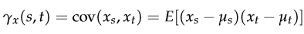
- Assuming that the time series mean miu_s = miu_t = 0, this provides some insight on the linear dependence of two time points, regardless of time progression. If the autocovariance function is applied to the same time point (s=t), it would simply be measuring the variance.
- Drawing parallels to the Pearson Correlation Coefficient equation between two series (X ,Y):
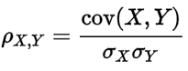

the Auto-correlation function (ACF) of two time points (x_s, x_t) is defined as:
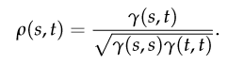
With the denominator as the square root of the variance product between the two time points, the ACF provides a “normalised” correlation measure between the two time points and should range between -1 to 1.
To see the effects of ACF, let’s take a look at some simulated data. Assume a time series of autoregressive AR(1) series, where x_t is dependent on the time point before it (t-1).

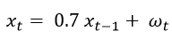

Tests
- Augmented Dickey-Fuller (ADF) Test
Augmented Dickey Fuller test (ADF Test) is a statistical test used to test whether a given Time series is stationary or not
- Ljung–Box test
The Ljung (pronounced Young) Box test (sometimes called the modified Box-Pierce, or just the Box test) is a way to test for the absence of serial autocorrelation, up to a specified lag k.
Arima: Autoregresive Integrating Moving Average
The fact of introducing ARIMA models comes from the assumption that we are not working with a non stationary dataset series. We say that time series datasets are stationary when their means, variance and autocovariance don’t change during time. The mayority of economic time series are not stationary, but differencing them determined number times makes them stationary. Whit this previous operation we can apply ARIMA models to any stock price. In general we say that a temporal set Yt admits an integrated autoregressive representation with p, q and d moving average orders respectively. We denote this forecasting model by ARIMA( p, d, q).
Yt=c+ϕ1ydt−1+ϕpydtp+...+θ1et−1+θqetq+etYt=c+ϕ1ydt−1+ϕpydtp+...+θ1et−1+θqetq+et
In ARIMA, p denotes the number of autoregressive terms, d denotes the number of times that the set should be differenciated for making it stationary. The last parameter q denotes the number of invertible moving average terms.

Correltion Between BSE and NSE (Predicting Values)
Pearson correlation of BSE and NSE = 1.000
P-Value = 0.000

Conclusion
The correlation between BSE and NSE (historical data) is 0.998 and the correlation between BSE and NSE (prediction values) is 1 i.e. we calculating the prediction values are nearly correct.

Graphs (BSE)

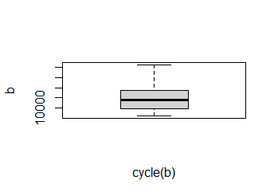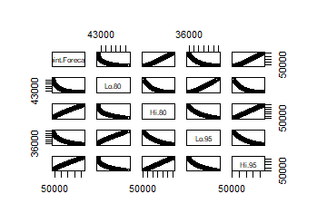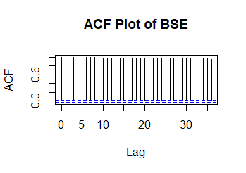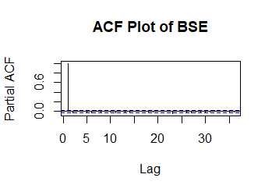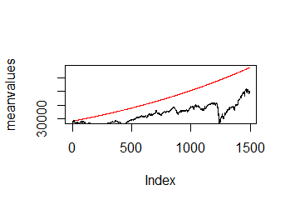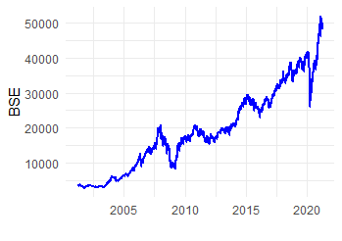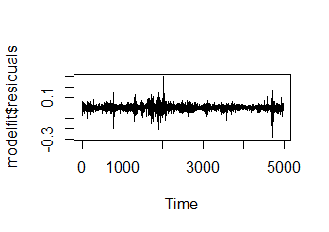

Graphs (NSE)
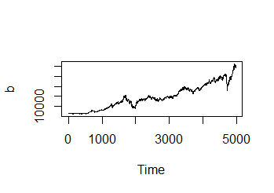

Reference
https://www.analyticsvidhya.com/blog/
https://rpubs.com/kapage/523169
https://www.kaggle.com/rohanrao/nifty50-stock-market-data

Data collection
https://www.bseindia.com/
https://www1.nseindia.com/
https://in.finance.yahoo.com/
https://www.marketwatch.com/

R code (BSE)
library(readxl)
library(Quandl)
library(tidyverse)
library(ggplot2)
library(tidyquant)
library(tseries)
library(forecast)
library(lubridate)
library(openxlsx)

BSE<-read_excel("D:/project/COMPLETE/EXCEL DATA/20 yr NSE
BSE.xlsx", sheet = "BSE")
a<-BSE$Close
b<-ts(BSE$Close,start = c(2001,4),end=c(2021,3),frequency =249.05)
b<-b[1:4974]
plot.ts(b)
boxplot(b~cycle(b))
p <- ggplot(BSE, aes(x=Date, y=Close)) +
geom_line(color="blue", size=0.8) +
theme_minimal() +
xlab("") +
ylab("BSE")
p##Increasing trend observed

####To check stationarity
adf.test(a, alternative="stationary", k=0)

#IF p-value is less than 0.05 so this implies that ts is stationary
b1<-acf(b, plot = T, main = "ACF Plot of BSE")
b2<-pacf(b, plot = T, main = "ACF Plot of BSE")
# ACF loooking good,As lag increases-fast decrease in ACF value- all in Confidence Interval

#We apply auto arima to the dataset
modelfit <- auto.arima(b, lambda = "auto");modelfit
plot(modelfit$residuals)
Box.test(modelfit$residuals, type="Ljung-Box")
f<-forecast(modelfit, h=365)
f= data.frame(f)
q <- plot(f)
head(f$lower)
head(f$upper)
head(f$mean)

###Below work is optional######
#Dividing the data into train and test, applying the model
N = length(a)
n = 0.7*N
train =a[1:n]
test = a[(n+1):N]
trainarimafit <- auto.arima(train, lambda = "auto")
predlen=length(test)
trainarimafit <- forecast(trainarimafit, h=predlen)
#Plotting mean predicted values vs real data
meanvalues <- as.vector(trainarimafit$mean)
precios <- as.vector(test)
plot(meanvalues, type= "l", col= "red")
lines(precios, type = "l")

####Now Exporting data####
a=write.xlsx(f,file="BSE.xlsx");a

